Module 4 – Medium Kit: Tanks, Separators, Heat Exchangers and Boilers
We will now discuss how specific units work and their function in a facility, and then directly apply all the content we have learnt previously to specific problems. So, we will be able to look at the control of these units in P&ID schematics we learnt in Module 2.

Outline
Primary learning outcomes for the module:
- Understand processes and design of: tanks and pressure vessels, separators, heat exchangers, and boilers
- Apply basic enthalpy and heat transfer equations to a range of heat exchanger configurations
- Analyse, describe and design control schemes for heat exchangers and boilers

4.1 Tanks and Pressure Vessels
A storage tank is a term used for a container that holds liquids and compressed gases but at close to atmospheric pressure (it is not designed for significantly elevated pressures or vacuum conditions). This is distinct from a pressure vessel which is designed for holding liquids or gases at pressures significantly away from atmospheric conditions, so it will have a larger wall thickness and pressure rating.
If a tank is holding a flammable liquid, it is desirable not to have any oxygen in the cavity space at the top of the tank (if the tank is only partially full). This means storage tanks sometimes have a floating roof (the roof of the tank moves up and down with the liquid level so there is no vapour space at the top) or for fixed roof tanks, the space at the top is often nitrogen blanketed (nitrogen is used to fill the vapour void space at the top of the tank).
A pressure vessel can be designed for any storage pressure, but in a normal storage tank the main source of pressure in the vessel can be the hydrostatically induced pressure from the contained liquid (hydrostatic head meaning the pressure from the weight of the liquid).
Just like for a manometer calculation in Module 3, the hydrostatically induced pressure from a liquid can be calculated from the weight force of the liquid:
ΔP = ρ_{f} g h
Where ΔP is the hydrostatically induced pressure (difference in pressure between the top and bottom of the liquid level)
ρ_{f} is the density of the liquid
h is the height of the liquid
g is the acceleration due to gravity (9.8 m/s² at the surface of the earth).
An example of this hydrostatically induced pressure is if you dive to the bottom of a pool and feel a force in your ears (the weight force of the liquid water above you). As a guide, diving 10m below the surface is equivalent to 1 additional atmosphere of pressure.
When draining a tank, it is important that no vacuum is created at the top of the tank. This can either stop the flow (if the design pressure of the tank is larger than the hydrostatically induced pressure difference) or can cause the tank to implode (if the design pressure of the tank is less than the hydrostatic head).
As a simple everyday example: Imagine putting a straw into your glass of soft drink. If you put your thumb over the mouth end, and raise the straw up, you can lift soda out of the cup within the straw. If you remove your thumb, the drink immediately drains out. Putting your thumb over the end of the straw means that when the liquid goes to flow out, it creates a small vacuum at the top of the straw, that acts against the hydrostatic weight force of the liquid in the straw (thus preventing it from flowing out). Only by releasing this vacuum at the top of the straw is the liquid able to freely drain out of the straw.

Worked Example 4.1
A closed roof tank is used for storing water. The tank can freely vent to atmosphere, so when the tank is filling, air at the top can be pushed out. If the positive displacement piston pump (P-01) is off, water can still freely drain out by opening V-01 (note that a positive displacement piston pump cannot have liquid ‘sucked through’ it, the way a rotary pump could if there was a downstream low pressure; it’s not open on both sides). So if the system is open to atmosphere, the pressure at the surface of the liquid water is always at atmospheric pressure.
In error, one day V-02 is closed. P-01 is off (liquid cannot be pulled through the pump so this is essentially a closed valve). The tank has a liquid height of 5m. If the tank has been rated to a differential pressure of +2atm (it will not rupture unless the internal pressure is 2atm larger than the external pressure) and -0.4 atm (it will not implode unless the internal pressure is 0.6 atm less than the external pressure) will the tank implode?
What changes could be made to the design to better protect the tank?

4.2 Separator
A separator is a pressure vessel used for separating a multiphase flow into different streams (usually gas and 1 or more liquid phases). It can be used when transporting steam as a trap to collect condensate (separating steam and liquid water that may have condensed in the line). In the oil and gas industry, 3-phase separators are used for separating raw oil from a well head into natural gas, crude oil, and a water-rich stream (the oil and water will phase separate out, making 2 liquid phases).
Separators work on the principle that different phases have different densities, which allows them to stratify due to ‘gravity’ settling (gas on the top and most dense phase on the bottom). A 3-phase separator will usually contain a weir, the allows the lighter liquid phase (usually oil) to spill over, while the heavier liquid phase (usually water) to remain behind. A gas stream can be collected in the overhead space (usually after passing through a demister to collect any entrained liquid mist).
3 Phase separators are usually fitted with a pressure safety valve (PSV) if the system pressure builds up. The PSV is a spring-loaded valve, that pushes down to keep the valve closed with a pre-defined force. If the system pressure exceeds this set tension (a mechanical set-point) the valve is forced open, and the gas is allowed to vent. The PSV will usually be set to a pressure 10-20% below the pressure rating of the vessel (providing a last line of defence to prevent catastrophic failure). One possible sample control scheme for a 3-phase separator is shown below.

4.3 Heat Exchanger
Heat exchangers are used to move thermal energy between liquid streams, but usually without the streams coming into physical contact (usually the 2 liquids are separated by a physical wall). They can be used for both heating and cooling operations on a process stream. Heat exchangers are used throughout your day in a range of devices (few simple examples below):
- Refrigerator: a fridge has an air-cooled condenser at the back of the unit (the back of your refrigerator often feels hot) which exchanges heat between the working fluid in the fridge and the surrounding air.
- Gas heaters. When using a gas heater, you do not burn natural gas and let the hot fumes fill your house (that creates a risk of carbon monoxide poisoning). Instead, you burn the methane, which then heats a ‘hot box’, so that air can be blown through, which is heated and goes into your home. The exhaust gases from the combustion are sent via a chimney flue to the outside. So, the air and flue gases are physically separated from mixing by the walls of the hotbox.
- Hot water systems. If you have a gas hot water system, the gas is burnt to heat up a vessel of water. Like the gas heater, the methane combustion flue gases and the water do not come into physical contact. So, they exchange heat.
- Cars. The radiator in your car (if it is a combustion engine, as opposed to an EV) is used to cool the engine while it runs (the coolant in a car is usually water, which may also contain ethylene glycol to lower its freezing point).

The enthalpy change experienced in one of the streams (assuming no phase change) can be given by:
$ΔH= m C_{P} {ΔT}_{fluid}$ or $Δ\dot{H}= \dot{m} C_{P} {ΔT}_{fluid}$
m is the mass of the liquid (kg). Or it can be expressed as $\dot{m}$, as a mass flow rate (kg/s)
C_{P} is the specific heat capacity (J/kg K)
ΔT_{Fluid} is the change in temperature (K or °C, as it’s a difference in temperature these will be the same). This temperature change refers to the change in temperature of the liquid (as it is heated or cooled).
This means ΔH is the change in enthalpy (J). Or it can be expressed as a flow of energy $Δ\dot{H}$ (J/s) meaning the change in enthalpy of the stream per second.
What is the physical origin of this? In a single phase (e.g., a liquid) we can think about the amount of energy that is has as relative to the system temperature- the temperature gives a measure of the kinetic energy motion of each atom, so multiplying the temperature by the amount of matter (the mass) and a constant that relates energy and temperature (heat capacity) gives a way to determine the total energy of the system. Adding or removing energy from the system (by heating or cooling it) will change this total energy.

Imagine a process stream is leaving a reactor at a high temperature and we want to cool it to constant lower temperature. The process stream is sent to a heat exchanger and the flowrate of cooling water can be tuned to keep the process stream temperature at a defined set point. A sample control scheme is shown below:
Thinking about an energy balance around the heat exchanger. If no energy is lost to the surroundings across the system boundaries, then any energy lost by the process stream must be gained by the cooling water. Or to express it another way:
$$\left|{ΔH}_{Process stream}\right|= \left|{ΔH}_{Cooling water}\right|$$
The conventions for energy changes can be a little confusion. In this case the process stream is losing energy (it’s getting cooler) while the cooling water stream is gaining energy (it’s getting warmer). So, when talking about the streams, we would say the process stream has a negative enthalpy change and the cooling water undergoes a positive enthalpy change. But if we were talking about the system boundaries in the example above, the process stream tends to add energy to the system (it comes in hot and leaves cold, so dumps some energy into the system) but the cooling water comes in cold and leaves hot (it takes energy from the system).
If energy is also lost across the system boundaries, then the process stream might be cooled by a little bit extra (due to heat leakage). So, we could write:
$${ΔH}_{Process stream}+ {ΔH}_{Cooling water}+ {ΔH}_{environment}=0$$

So, we can complete the energy balance between the 2 streams (and use a term to account for any environmental losses). But if we’re given the specific dimensions of the heat exchanger, can we calculate how much energy is transferred between the streams? (If the heat exchanger is larger, we might intuitively expect more heat transfer). How can we size our heat exchanger or if we are given all the physical dimensions and properties of an existing heat exchanger, can we calculate the heating duty we might expect? Yes, we can solve this, and we’ll discuss it next.
To reason through an answer from a physical perspective, we’ll begin with a simple thought experiment: Imagine a metal rod is heated on a stove until it becomes red hot. Dropping the rod into a pot of water causes the water to boil vigorously and bubble up everywhere: we can conclude there has been a large and fast transfer of thermal energy into the water (causing a phase transition or bubbles of steam that cause the violent bubbling). We remove the rod from the water and heat it again over the flame, but only until it is lukewarm. Dropping it into a fresh pot of water, we observe the water gradually heat up, but there is no vigorous boiling as in the first case. We can conclude that less energy has been transferred to the water (the rod contained less thermal energy when dropped in), but also that the rate of energy transfer has occurred much more slowly.
The conclusion we might draw from this is that the rate of heat transfer (the speed at which thermal energy is transferred from the rod into the water) is proportional to the temperature difference between the 2 materials (we can think of the temperature as an amount of thermal energy per atom). The large temperature difference in the first case causes a high rate of energy transfer. The smaller temperature difference in the second case means the rate of energy transfer is much smaller. To express the result another way: the temperature difference provides the driving force to energy transfer. In later subjects, you will also learn analogous principles that a concentration difference can provide a driving force to mass transfer (diffusion) and a velocity gradient can create a shear stress (momentum transfer).
To express our finding on thermal energy transfer mathematically, we could say the heat flow (Q, also called the duty, J/s) is a function of the temperature difference (ΔT):
Q =f(ΔT_{between fluids})

Now imagine the rod was much larger is size, or more specifically if it had a larger surface area for the same mass. When dropping it into the water, we might expect the thermal energy could discharge much faster. There is more contact area between the hot surface and the bulk liquid, so more places for the energy to transfer through. So, our second finding could be that:
Q = f(ΔT_{between fluids} ,A)
Heat flow (duty) is dependent on the area (through which the heat transfer takes place, A). This area is not the cross-section of the rod, but the external area of the rod that contacts the liquid phase.

Finally, we can see the rod rapidly discharges its thermal energy when dropped into water, but it does not rapidly lose this energy in the air (it will cool gradually in the air but at a much slower rate than in the water). If it were in the air, we could blow on it to cool it faster (like blowing on hot soup). So perhaps we can conclude there is some material effect, where a physical property of the phase that surrounds the rod, and its motion, changes the rate of thermal energy transfer. We refer to this as the heat transfer coefficient (U) and it is a material property of the 2 phases (the metal and the water/air) as well as their interfacial effects as well as bulk conditions (like the movement of the surrounding liquid phase). We often imagine the interface as having an immobile layer of fluid at the surface (often called a laminar boundary layer). This layer of fluid tends to impede the heat transfer, as the heat needs to conduct through it. But if we mix the fluid over this boundary layer, convection helps carry the energy away from the surface through the bulk flow of the liquid phase. This can help explain why blowing on the surface can help cool it (we’re constantly exchanging the warm air around the surface with low temperature air). Heat exchangers are sometimes designed with baffles, to help fluid flow patterns to aid this mixing.
Bringing all terms together, to express it mathematically now, we can say the heat flow is then a function of these 3 properties of the system:
Q = f(ΔT_{between fluids} ,A, U)

From experiment, we find that the heat flow is linearly proportional to each one of these parameters: doubling the temperature difference, doubles the heat flow if everything else is equal; doubling the heat transfer area doubles the heat flow if everything else is equal.
So, the relationship can be expressed as:
$Q=U A {ΔT}_{between fluids}$
Where:
Q = heat duty (flow of energy, J/s)
U = heat transfer coefficient (J/s m² K)
A = area for heat transfer (m²)
ΔT_{between fluids} = temperature difference (between the 2 streams, not the change in temperature in one stream, ºC or K- as this is a difference, these units give the same result)

Imagine a scenario where a hot process stream is being cooled by cooling water. The process stream enters a heat exchanger at high temperature, then as it passes through it and loses thermal energy by contacting the colder cooling water stream. So, the process stream is cooled as it passes through the exchanger, while the cooling water is heated as it moves through (this is sometimes called a co-current heat exchanger arrangement).
If the system is well insulated and there are no energy losses to the environment, then we can say:
Q = m_{process stream} C_{Pprocess stream} ΔT_{Process stream} = m_{cooling water} C_{PCooling Water} ΔT_{Cooling water} = U A ΔT_{between streams}

From an overall energy balance, the energy lost by the process stream must match the energy gained by the cooling water stream. And, also, for the specific design of the heat exchanger, this duty moved between streams must also equal the energy moved through the walls of the heat exchanger.
The situation is represented in the diagram below:

One problem now arises: The difference in temperature between the two process streams is not constant. It varies as a function of length through the heat exchanger. This heat exchanger has been designed in a co-current flow configuration (both streams flow in the same direction). So, the temperature difference between the 2 flow streams is greatest at the inlet, then they tend towards a common point (they asymptote towards a weighted halfway point).
A more accurate way to write the heat transfer between the 2 streams is then to write it in the differential form:
dQ = U A dT
The duty between the 2 streams (Q) is then the integral for all possible temperatures along the length of the heat exchanger. One way to approximate this solution, for constant U along the length of the heat exchanger (no temperature dependence in U) is to take an average temperature. But we use the log-mean temperature difference between the 2 streams (not the average temperature difference).
$${ΔT}_{LM}= \frac{{ΔT}_{between fluids 1}- {ΔT}_{between fluids 2}}{Ln\left(\frac{{ΔT}_{between fluids 1}}{{ΔT}_{between fluids 2}}\right)}$$

So Q = U A ΔT_{LM} = m_{process stream} C_{Pprocess stream} ΔT_{Process stream} = m_{cooling water} C_{PCooling Water} ΔT_{Cooling water}

4.3.1 Co-current vs Counter Current
In the example above, the flow configuration is drawn as a co-current arrangement. The 2 streams flow in the same direction through the heat exchanger. The hottest part of the hot stream (the process stream) and the coldest part of the cold stream (the cooling water) contact at the same point and trend towards a common mid-point (a weighted average temperature). If the heat exchanger is made larger (larger A) the system tends closer towards this mid-point, but can never reach it (it as an asymptote). As the 2 streams approach thermal equilibrium, the driving force to heat transfer keeps getting smaller and smaller.
An alternative arrangement is a counter-current heat exchanger flow configuration. In this arrangement, the flows of the streams are in opposite directions in the heat exchanger. The hottest part of the hot stream contacts the hottest part of the cold stream. The coldest part of the cold stream contacts the coldest part of the hot stream. So, in this arrangement, there is always a larger temperature difference maintained between the 2 streams, which maintains a larger driving force for the heat transfer.
In a counter-current heat exchanger, the outlet temperatures of the hot and cold stream can pass the weighted average temperature, so for a given sized area heat exchanger (fixed area) it can produce a larger temperature change in both fluid streams.
This is an important point to understand, because all the internal configuration stays the same. Just by changing a little bit of piping and switching the inlet/outlet of a single stream, you can often produce a 10-25% improvement in the heat exchanger performance; it just comes from understanding how the system works. Most importantly, you don’t need to take my word for this. In the Fun CE practical, you will design and build a heat exchanger, then test it in the wetlabs. So, you will have the opportunity to test this statement for yourself (if you would like to).

Minimizing the capital costs of a heat exchanger usually means minimising the required area (which reduces the size and amount of material required) for a given heat transfer duty. Minimizing the area therefore comes by maximising the temperature difference (for example by changing the flow configuration) or by increasing the heat transfer coefficient (this can be by using material with a high thermal conductivity or arranging a flow configuration to improve heat transfer, such as using baffles).

4.3.2 Type of Heat Exchangers
There are many different physical designs for heat exchangers. All the theory we have discussed in this sub-section remains the same, but how the flow is laid out (and how the heat transfer area is arranged) may change for specific industrial needs and for ease of fabrication (as tubes and pipes come pre-manufactured, it is easier to build equipment from this rather an irregular custom design).

- Shell and tube heat exchanger. A series of tubes inside of a larger shell, where one fluid can flow through the tubes, while the other fluid flows around the tubes through the shell. Perhaps the most common type of heat exchanger and widely used in the oil and gas industry.

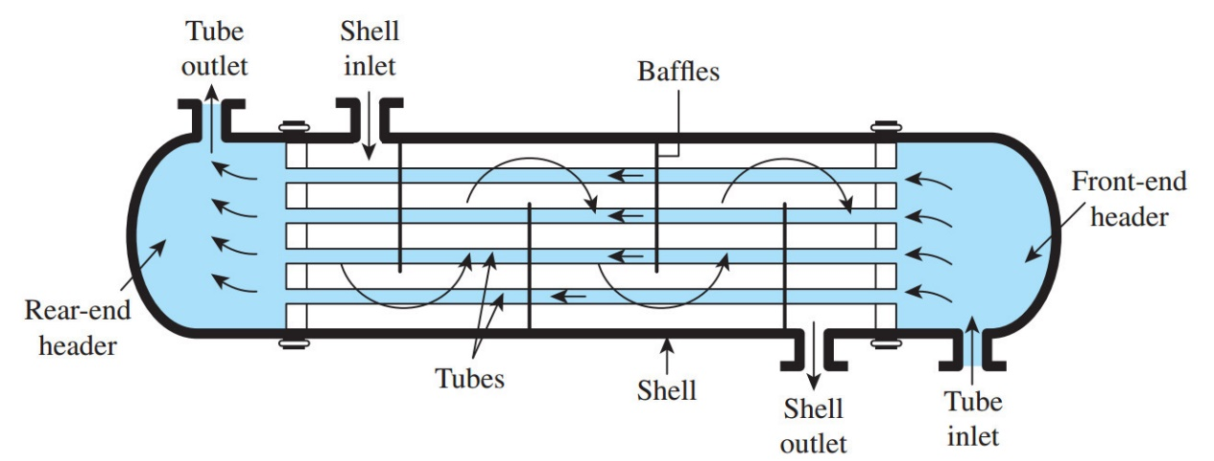
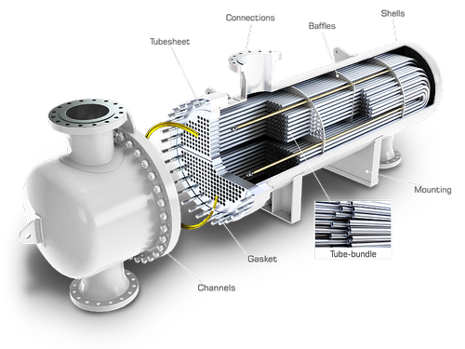

- Plate heat exchanger. These are widely used in food handling because they can be easily opened and cleaned and have few dead spaces for bacteria to grow. So, for example plate heat exchangers are commonly used to pasteurize milk.
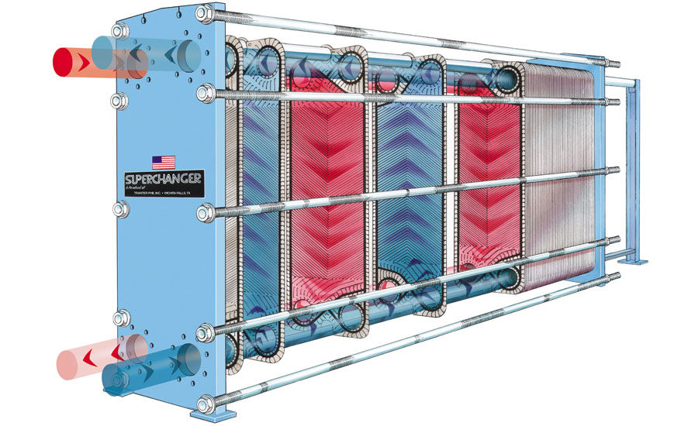

- Co-axial heat exchanger. This is a very rare type of heat exchanger because it is difficult to service. AutoCAD Plant 3D and Visio don’t have a pre-defined P&ID symbol for this unit. But it is arranged as a pipe within a pipe, so a jacket always surrounds the tube. (I’ve really just included it here because it is easy to understand and build, so might be of help when thinking about your practical).
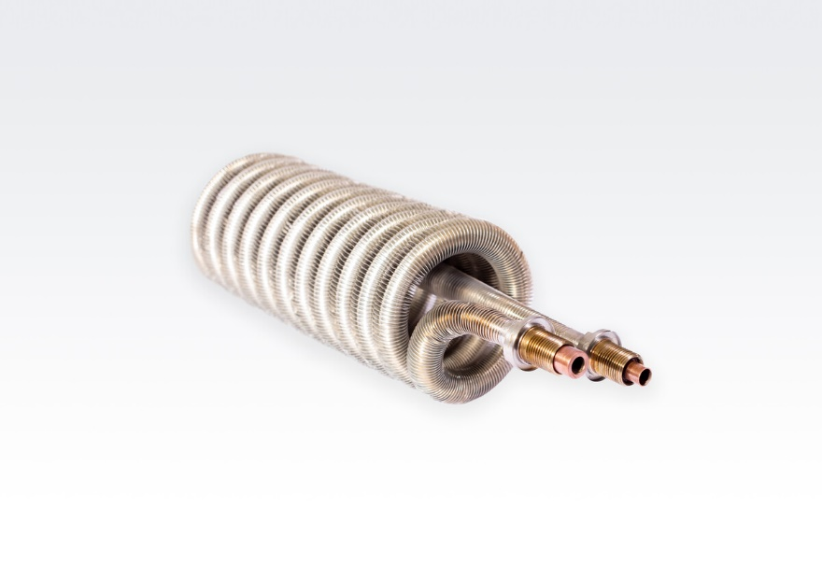
A common problem with all types of heat exchangers is fouling. If material attaches to the heat transfer surface, it can act like insulation to increase the resistance to heat transfer (lowering U and reducing the heat exchanger performance). This is particularly common when processing heat sensitive fluids. For example, in the pasteurization process, milk is heated for a short period of time to kill bacteria. But overheating the milk or leaving it at elevated temperature for too long can ‘cook’ the milk (denature the proteins) which can cause it to stick to the surface. Removing the fouling layer usually means shutting down the process, opening the heat exchanger and manually cleaning off any solids attached to the heat transfer surface.

Worked Example 4.2
Consider the control arrangement of the heat exchanger below. The shell side and tube side are both full of liquid (there is no room for a liquid hold up). Will the control arrangement work? Explain your reasoning. You can think about a degree of freedom analysis or the mathematical operations from above.

Worked Example 4.3
Consider the control arrangement of the heat exchanger below. The shell side and tube side are both full of liquid (there is no room for a liquid hold up). Will the control arrangement work? Explain your reasoning. You can think about a degree of freedom analysis or the mathematical operations from above.

4.4 Boilers and Power Generation
Boilers are used to produce steam. The latent heat of steam is very high (relative to other fluids) so steam can be used to move energy throughout a plant (i.e., heating steam). Steam can also be superheated beyond its boiling point and used to drive a turbine to generate electricity (i.e., high pressure superheated steam). In both cases, the steam is generated within a boiler.
Boilers function like a heat exchanger, in that energy supply energy to a fluid stream (typically water). But boilers are designed to generate a phase change to create steam. So, although the core principles and heat transfer theory are the same, the physical design, layout and control can differ from a heat exchanger design.
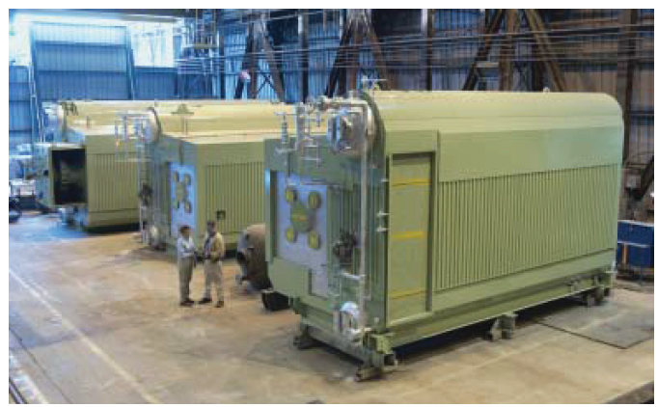
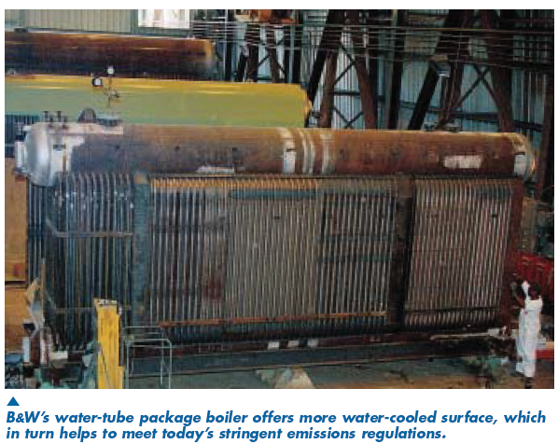

A steam generator usually consists of 2 drums: an upper drum (commonly called the steam drum) and a lower drum (commonly called the mud drum). Tubes called the down-comer connect the steam drum and mud drum. The down-comer tubes do not go through the furnace so the water passing through here has comparatively higher density and will tend to sink (thus the name ‘down-comer’). A second set of tubes connects the mud drum back to the steam drum, but these pass through a furnace; water in these lines boils and rises, driving the steam and any unboiled water back to the steam drum and forcing recirculation of the water between the drums.
In the steam drum, the saturated steam is separated from the boiling water for use within the plant (e.g., generating power, or as a heating utility). Impurities entering in the boiler will tend to accumulate in the lower drum, as the water is boiled off (hence the name mud drum). So, at periodic intervals a valve on the bottom of the mud drum is opened to push out the accumulated sediment (a process known as blowdown).
Most boilers are designed to keep water at a minimum level in the steam drum, so water remains in the down comer. Without water recycling in the system, many furnaces will over-heat.
As the water in the steam drum is at its boiling point, the only way to change the temperature of the steam generated by the boiler is to change the temperature of the steam drum. Increasing the fuel flowrate in the furnace will only increase the rate at which the water boils; it cannot change the outlet temperature of the saturated steam (for example turning up the gas on a pot of boiling water does not change the temperature the steam boils at, it only changes the rate as which steam comes off the pot). After the steam has left the boiler, we can drop the pressure of the line to produce superheated steam (steam heated beyond its boiling point). Usually, superheated steam would be used to drive a turbine to generate power (because the turbine is only designed to handle vapour and any condensation on the turbine blade can damage them). If the steam is being used to move energy it would be kept closer to saturation, because steam has a low specific heat capacity but a high latent heat; the energy in the steam comes from condensing it to a liquid, not heating it beyond condensation to superheated conditions. Super-heating the steam a little bit beyond saturation (from a small pressure drop) can reduce condensation in the pipelines as it cools (due to incomplete insulation on the line).

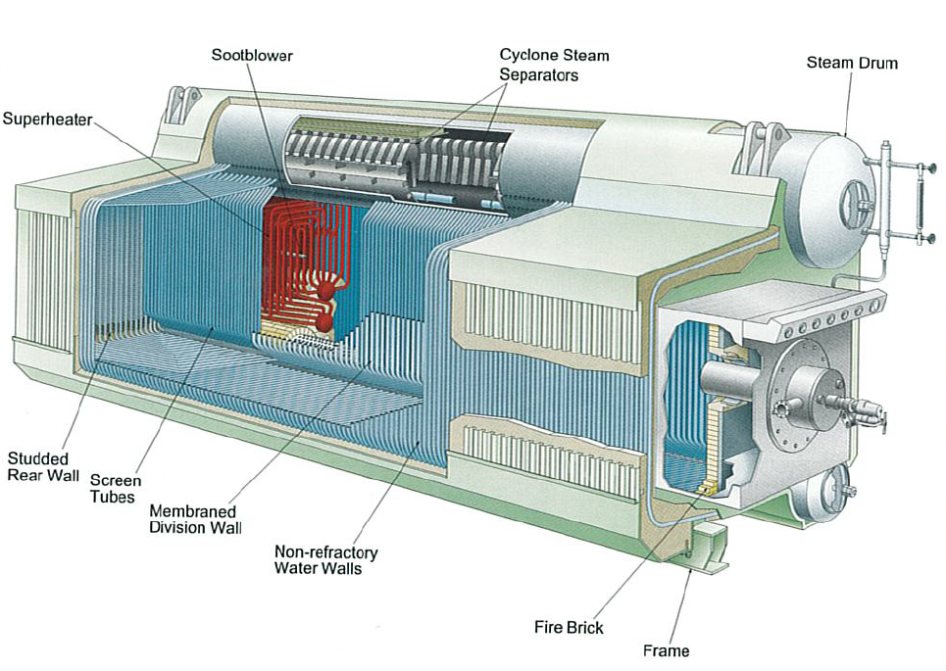
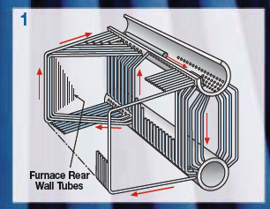

Worked Example 4.4
Based on your understanding of the operation of a boiler, sketch a control scheme for the simplified steam boiler schematic below.
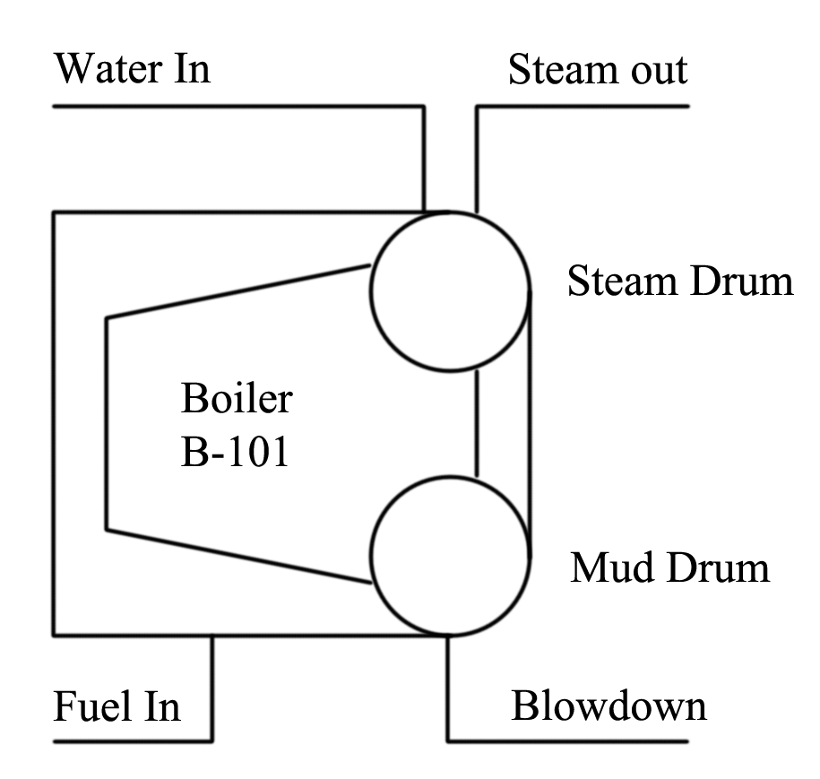


4.4.1 Steam
Boilers will produce steam at the highest pressure required in the system (it’s easy to drop the pressure of the steam after the boiler but relatively expensive to try to increase the line pressure with compressors). Pressure energy from the steam line can be converted to electricity (with a turbine) which generates lower pressure steam. For grades of steam (and normal operating ranges of a boiler):
Low pressure steam | 5 bar gauge | 160ºC
Medium pressure steam | 10 bar gauge | 184ºC
High pressure steam | 40-50 bar gauge | up to 250ºC

If you want to heat process streams above 250ºC it would usually be done with hot oil or direct heating, rather than with a steam line.

Once the steam has been generated, it needs to be distributed throughout a plant. Steam distribution can sometimes cause losses as high as 60% (pressure drop losses, inadequate insulation etc). Steam condensate is usually collected and returned to the boiler for reuse; it saves the energy required to heat the water from ambient conditions up to the boiling point. But collecting this hot water requires a condensate trap in a steam line and a condensate pipeline to return the water.

Steam Trap
A steam trap is a device designed to pass liquid water but hold up steam. It is used in the condensate trap above to prevent steam from leaving in the condensate line. It could also be used on a heat exchanger, to ensure any water entering as steam condenses in the exchanger before leaving.
Steam traps can be designed on a range of different principles, but a common one is a mechanical trap that passes liquid water (but holds up steam) based on the density of the fluid (i.e., a float trap).
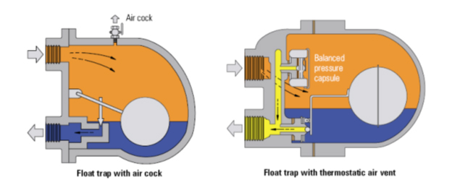

Module 4 Summary

Key points:
- Tanks and pressure vessels
- Separators
- Heat Exchangers:
  - Heat transfer (enthalpy)
  - Configuration (co-current vs. counter-current)
  - Types (shell and tube, plate, co-axial)
- Boilers

Key Skills:
- Understand design, operation, and safety features of the above equipment
- Analyse, describe, and design heat exchanger control

